Resume
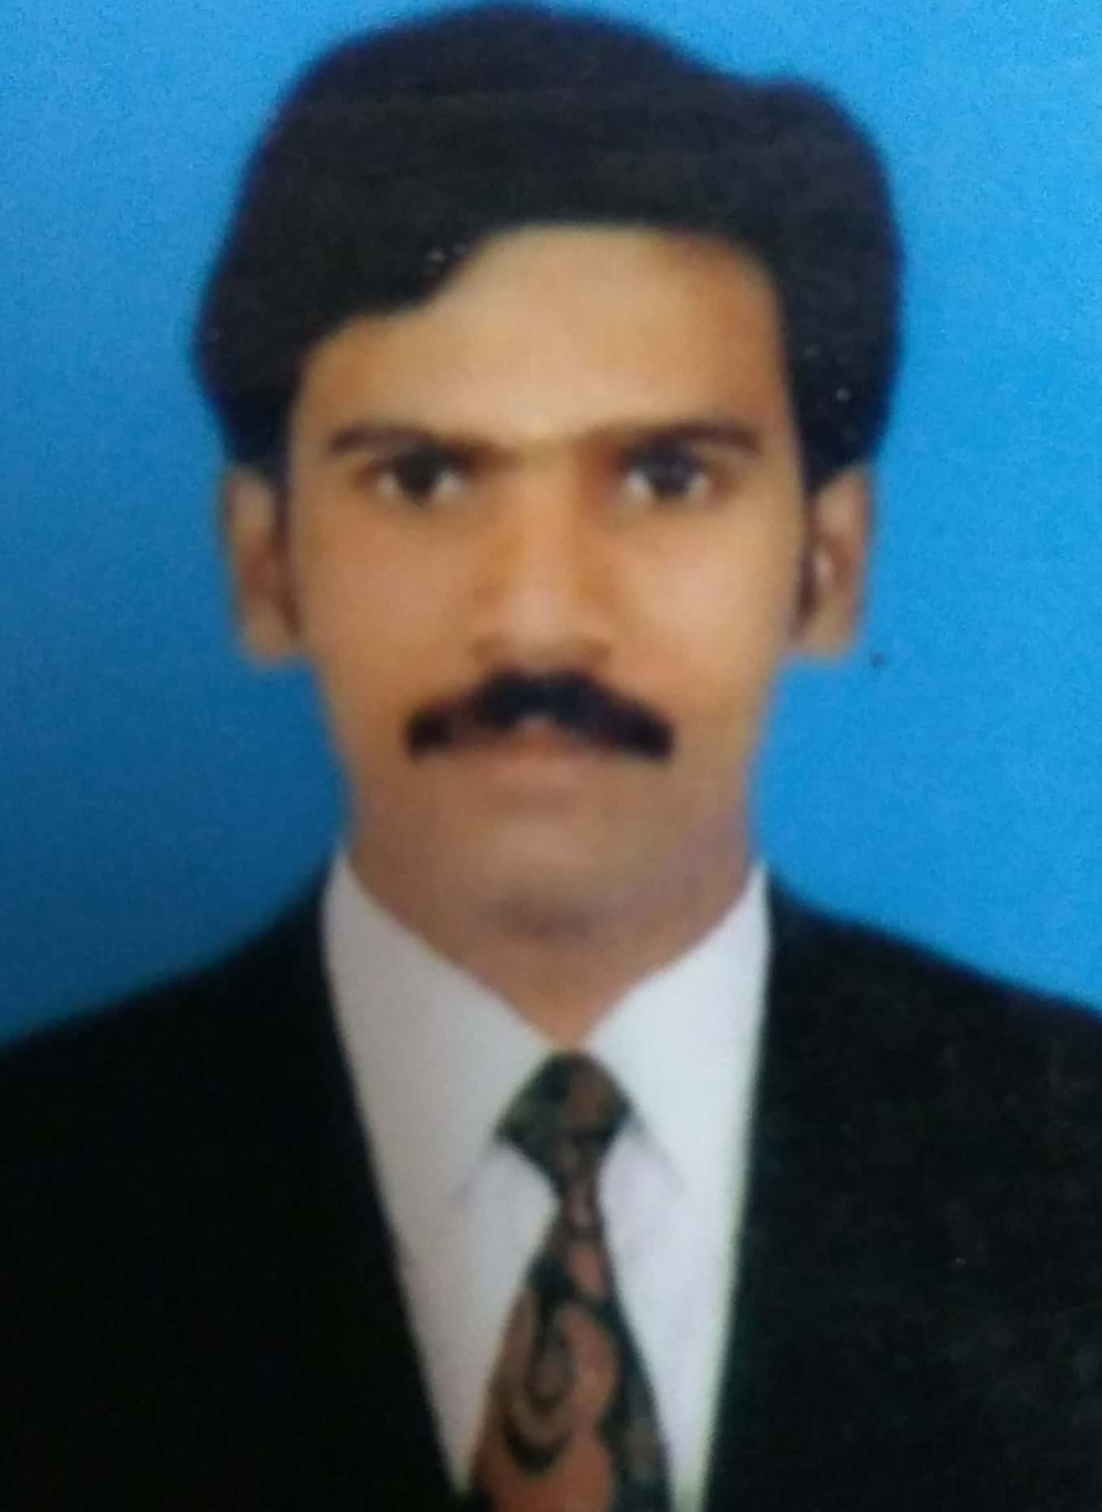
Rajagopal.S
Email : Srg.thrisha@gmail.com
Mobile: +91 98840 53087

Career Objective: To be part of a highly motivated team and use my diverse background to obtain a challenging position in an esteemed organization.

Professional Summary

- Dynamic professional with 20+ years of experience in Collections (Both Field and Tele calling) & Team Management.
- Expertise in managing all service operations key focus on top line / bottom line profitability thereby ensuring optimal utilization of resources.
- Learned to value commitment and goal setting, time bound & result oriented mission & initiatives. Experience of handling collection operations Team.
- Deft at handling day to day activities in co-ordination with internal / external departments for smooth business operations. Experience of handling collections operation.
- A proactive leader and planner with expertise in strategic planning in collection portfolio.
- Maximum Team size handled – 150 FOS and 140 Tele-callers.
- Exposure on products handling capacity – PL, TW, Home Loan, Auto Loans, Used car loans & Commercial vehicle.
- Exceptionally well organized with a record of accomplishment that demonstrates self-motivation, creativity, and initiatives to achieve both personal and corporate goals.

ORGANISATIONAL EXPERIENCE

Mar 2023 till date – Piramal Capital and Housing finance Ltd – Branch Recovery Manager.

Dec 2018 till Feb 2023 Alphentrix Global Services Pvt Ltd – Senior Manager Collections cum operation.

Mar 2018 to Dec 2018 First Abu Dhabi Bank – Collection Officer

Jul 2017 to Nov 2017 Riddhi Corporate Services Ltd – Business Development Manager.

Jan 2016 to Mar 2017 Reliance Communication Ltd – Recovery Collection process & Call center

Sep 2011 to Jan 2016 RETCOL MANAGEMENT SERVICES – Reliance process Collections cum Operation Manager & DUBAI Skip customer tracing team, Sales Manager ICICI Bank.

Oct 2005 to Sep 2011 Optimus Global Services (A BPO from Polaris group), ICICI BANK Process
- Asst Manager (Collection cum Operation)

Mar 2001 to Oct 2005 HSBC BANK (DSA)
- VRCS Backend Officer (Collection Process)

PROFESSIONAL EXPERIENCE:

Mar 2023 till date – Piramal Capital and Housing Finance Limited- Branch Recovery Manger.

Managing entire TN portfolio.

- Handling the products of UCL, UBL, PL & App loans of all the buckets and Recoveries.
- Portfolio size – 114 crs
- Experience in Agency Audits, Billing, Repo & Field collections.
- Responsible for Agency Management and portfolio performance.
- Maintaining trackers with respect to data input and daily movement.
- Conceptualizing and implementing the strategy for the collections.

Dec 2018 till Feb 2023 – Alphentrix Global Services Pvt Ltd - Senior Manager Collection cum operation.
Roles and responsibilities.

Managing both Domestic and International process.
Domestic:
Bajaj Finserve, L&T Finance, Fullerton India, Kotak,
International:
Etisalat, Dubai Islamic Bank & DU Telecom.

- Handling 0 till Recovery.
- Products Personal Loans, Two-Wheeler & Tele-com process
- Managing POS of 160 crores in Recovery including penal, TW – Buckets 7 crores. Tele-com – 346 million (Count - Around 1.2 lakhs of accounts)
- Portfolio Analysis in terms of Count, POS, Cycle Date & Repayment Mode.
- Handling both Tele-calling and Field. (2 Asst Managers, 6 Team Leaders ,85 Tele-callers & 22 FOS)
- Managing productivity to the best levels by being on par with daily DRR benefitting client and management.
- Maintaining trackers with respect to data input and daily movement’s month on month.
- Conceptualizing and implementing the strategy for the collections.

Mar 2018 – Dec 2018 – First Abu Dhabi Bank as Collection Officer
Role and Responsibilities.
- Managing Fresh flow customers with portfolio size of approx 30 million.
- Tracing customers like not contactable Skip & Fraud Customers by using good tracking tools.
- Ensuring achievement of 100% of the assigned targets.
- Implementing new workflow systems & ensuring compliance with set guidelines

Jul 2017 – Nov 2017 Riddhi corporate Services Ltd Business Development Manager.
Role and responsibilities.

- Meeting new clients to serve the client requirements by explaining the company profile and the potentials.
- Analyzing the prospective client base to suit our requirements.
- Fixing up prior appointments and schedule appropriate meetings with the clients.
- Calculating the profit viability and planning accordingly.
- Organizing conference calls for the detailed requirements of business.

Jan 2016 – Mar 2017 Reliance Communication Ltd. (Recovery process) as Asst. Manager.
Role and responsibilities.

- TN Retail Recovery collection Lead for (TN) Jan’2016 to Mar-2017
- Managing 90 Plus Recovery Collections, with portfolio size of approx. 8.5 Crores, with the down line of 10 Agencies
- Tracing customers like not contactable Skip & Fraud Customers by using good tracking tools and arranging field visits.
- Coordinating with the overseas collection agencies for Not Contactable, Skip & Fraud customer’s feedback.
Resolving customer issues, negotiating settlements as per the guidelines as per the policy.
- Ensuring achievement of 100% of the assigned targets including backflow and normalization.
- Implementing new workflow systems & ensuring compliance with set guidelines.
- Reducing Bad debts from the recovery collections.

Sep 2011 – Jan 2016 RETCOL MANAGEMENT SERVICES (Reliance Process) India as Manager Collection.
Allset Deals with Major Telecom & Banking project in southern part of India
Role and responsibilities

- Monitoring day in and out collections by setting a credit day to all customers by segmenting into group.
- Analyzing mobility portfolios: product-wise, region-wise, POS–wise; Collection/Mob database allocation depending upon the constitution of POS
- Implied a new strategy to trace customers who’s overdue were more than 90 days.
- Handling team strength of 150 representative (Tele calling & Field) and 10 team leaders.
- Managing their productivity by setting a weekly and monthly DRR on the receivables.
- Maintaining trackers with respect to data input and daily movement’s month on month.
- Ensured that the minimum realization of 85% is met on every month from the receivables.

Achievements:
Have been recognized as best manager for achieving the super incentive slab for consecutive three months in my process during the period of 2013.

Oct 2005 – Sep 2011 M/s. Optimus Global services Pvt Ltd. India (ICICI BANK) as Assistant Manager Collections
Role and responsibilities are:
- Portfolio Analysis in terms of Count, POS, Cycle Date & Repayment Mode
- Have worked on different DPD (0 – 90) data’s of ICICI collection recoveries process.
- Handling different type of portfolio like HL, Auto Loan, TW, PL, CV & UC
- Managing productivity to the best levels by being on par with daily DRR benefitting client and management.
- Maintaining trackers with respect to data input and daily movement’s month on month.
- Conceptualizing and implementing the strategy for the collections.
- Coordinating with various departments of ICICI bank during various collection campaigns.

Mar 2001- Oct 2005 VRCS (HSBC DSA) India as Backend Officer
Key result areas / Job role: - HSBC BANK

- Co-ordinate with tele callers of HSBC operations who fixes up appointment to solicit payments from customer who holds HSBC credit card and whose credit card outstanding were in days-past-due of 30+
- Visiting the customer’s place to collect payment and issue receipt on behalf of HSBC.
- Negotiating with customers and in due course streamlining their payment obligations
- Imparting customers about the tenets of credit discipline and the rating mechanism in place for tracking default borrowers.

ACADEMIC CREDENTIALS

- Bachelor of Business Administration (BBA) – June2005

PERSONAL DETAILS

Date of Birth | 29th August 1980
Father’s Name | Swaminathan
Gender | Male
Marital Status | Married
Languages | English, Malayalam & Tamil (Mother tongue)
Nationality | Indian

References: References can be furnished upon request.

(Rajagopal.S)

